**Project**

**Swiggy Case Study**

Q1.a) Which category shows high demand during Diwali festival?

b) Which category shows high profit during Diwali festival?

c) Top 10 Shop names where demand is high during Diwali.

Q2.a) Which item has the maximum orders?

b) Which item has the minimum orders?

Q3) Number of busiest day(hr_0f_the_day = 23) for each shop?

Q4) Which city having more food delivering shop services by swiggy?

Q5) What is the sale of samosa on date 10-10-19 and in city 07?

Q6) Which item is most expensive?

Q7) Different Types of Burger.

**Solutions**

**Q1.a) Which category shows high demand during Diwali festival?**

**Answer:-**

-- before festival

select CATEGORY,count(*)

from swiggy_case_dataset_pre_post_diwali_sales_pre

group by category

order by count(*) desc;

-- after festival

select CATEGORY,count(*)

from swiggy_case_dataset_pre_post_diwali_sales_post

group by category

order by count(*) desc;

-- Data

select pre.category , pre.cnt pre_diwali_qty_sales , post.cnt post_diwali_qty_sales ,pre.cnt+post.cnt Total_Diwali_qty_sales

from (select CATEGORY,count(*) as cnt from swiggy_case_dataset_pre_post_diwali_sales_pre group by category) as pre ,

(select CATEGORY,count(*) as cnt from swiggy_case_dataset_pre_post_diwali_sales_post group by category) as post

where pre.CATEGORY=post.CATEGORY

order by Total_Diwali_qty_sales desc;

**Screenshot:-**

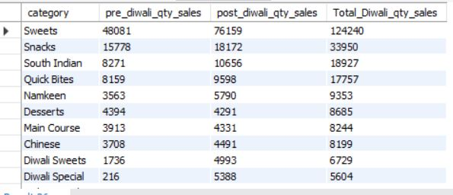

**Q1.b) Which category shows high profit during Diwali festival?**

-- before festival

select CATEGORY,count(*),sum(ITEM_GMV) as Total_Category_Sales

from swiggy_case_dataset_pre_post_diwali_sales_pre

group by category

order by Total_Category_Sales desc;

-- after festival

select CATEGORY,count(*),sum(ITEM_GMV) as Total_Category_Sales

from swiggy_case_dataset_pre_post_diwali_sales_post

group by category

order by Total_Category_Sales desc;

-- Data

select pre.category ,pre.Total_Category_Sales+post.Total_Category_Sales as Total_Sales_Before_After_Diwali

from (select CATEGORY,sum(ITEM_GMV) as Total_Category_Sales from swiggy_case_dataset_pre_post_diwali_sales_pre group by category) as pre ,

(select CATEGORY,sum(ITEM_GMV) as Total_Category_Sales from swiggy_case_dataset_pre_post_diwali_sales_post group by category) as post

where pre.CATEGORY=post.CATEGORY

order by Total_Sales_Before_After_Diwali desc;

**Screenshot:-**

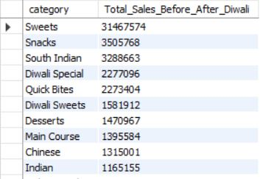

**Q1.c) Top 10 Shop names where demand is high during Diwali.**

-- Before Diwali

select NAME,count(*) as orders

from swiggy_case_dataset_pre_post_diwali_sales_pre

group by name

order by count(*) desc;

-- After Diwali

select NAME,count(*) as orders

from swiggy_case_dataset_pre_post_diwali_sales_post

group by name

order by count(*) desc;

-- Data

select pre.name ,pre.orders Before_Diwali_Orders,post.orders After_Diwali_Orders,(pre.orders+post.orders) Total_orders

from (select NAME,count(*) as orders from swiggy_case_dataset_pre_post_diwali_sales_pre group by name) as pre ,

(select NAME,count(*) as orders from swiggy_case_dataset_pre_post_diwali_sales_post group by name) as post

where pre.name=post.name

order by Total_orders desc

limit 10;-

**Screenshot:-**

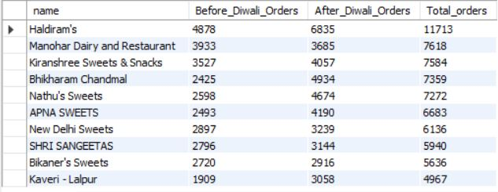

**Q2.a) Which item has the maximum orders?**

-- Data

select pre.ITEM_NAME ,pre.cnt+post.cnt qty_sales

from (select ITEM_NAME,count(*) as cnt from swiggy_case_dataset_pre_post_diwali_sales_pre group by ITEM_NAME) as pre ,

(select ITEM_NAME,count(*) as cnt from swiggy_case_dataset_pre_post_diwali_sales_post group by ITEM_NAME) as post

where pre.ITEM_NAME=post.ITEM_NAME

order by qty_sales desc

limit 1;

**Screenshot:-**



**Q2.b) Which item has the minimum orders?**

-- Data

select pre.ITEM_NAME ,pre.cnt+post.cnt qty_sales

from (select ITEM_NAME,count(*) as cnt from swiggy_case_dataset_pre_post_diwali_sales_pre group by ITEM_NAME) as pre ,

(select ITEM_NAME,count(*) as cnt from swiggy_case_dataset_pre_post_diwali_sales_post group by ITEM_NAME) as post

where pre.ITEM_NAME=post.ITEM_NAME

order by qty_sales asc

limit 1;

**Screenshot:-**



**Q3) Number of busiest day(hr_0f_the_day = 23) for each shop?**

select name,count(distinct dt) N0_Of_days

from (

select dt,name,hr_of_the_day

from (select dt,name,hr_of_the_day,rank() over (order by hr_of_the_day desc) as ranks from swiggy_case_dataset_pre_post_diwali_sales_pre) as pre

where ranks=1

union all

select dt,name,hr_of_the_day

from (select dt,name,hr_of_the_day,rank() over (order by hr_of_the_day desc) as ranks from swiggy_case_dataset_pre_post_diwali_sales_post) as post

where ranks=1

) A

group by name

order by name;

**Screenshots:-**

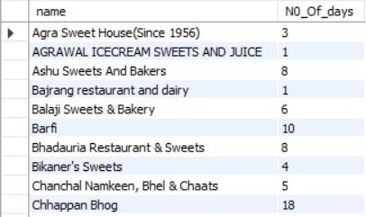

**Q4) Which city having more food delivering shop services by swiggy?**

select city,count(*) as No_Of_Shops

from (select city,name,count(city) from swiggy_case_dataset_pre_post_diwali_sales_pre group by city,name

union all

select city,name,count(city) from swiggy_case_dataset_pre_post_diwali_sales_post group by city,name) as pre

group by city

order by No_Of_Shops desc;

**Screenshots:-**

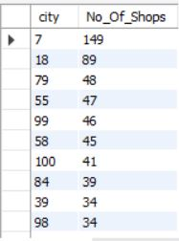

**Q5) What is the sale of samosa on date 10-10-19 and in city 07?**

select sum(ITEM_GMV) as Sales_Of_Samosa

from (select * from swiggy_case_dataset_pre_post_diwali_sales_pre

union all

select * from swiggy_case_dataset_pre_post_diwali_sales_post) as swiggy_table

where dt="10-10-19" and city=07 and ITEM_NAME like "%samosa%";

**Screenshot-**



**Q6) Which item is most expensive?**

select pre.ITEM_NAME,round((pre.Avg_Price_Of_Item+post.Avg_Price_Of_Item)/2,2) as Avg_Price_Of_Item

from (select ITEM_NAME,count(*) as No_Of_ItemName_In_Group,sum(ITEM_GMV) as Group_Item_GMV,sum(qty) as Group_QTY,sum(ITEM_GMV)/sum(qty) Avg_Price_Of_Item from swiggy_case_dataset_pre_post_diwali_sales_pre group by ITEM_NAME) as pre ,

(select ITEM_NAME,count(*) as No_Of_ItemName_In_Group,sum(ITEM_GMV) as Group_Item_GMV,sum(qty) as Group_QTY,sum(ITEM_GMV)/sum(qty) Avg_Price_Of_Item from swiggy_case_dataset_pre_post_diwali_sales_post group by ITEM_NAME) as post

where pre.ITEM_NAME=post.ITEM_NAME

order by ((pre.Avg_Price_Of_Item+post.Avg_Price_Of_Item)/2) desc

limit 1;

**Screenshot:-**



**Q7) Different Types of Burger.**

select distinct ITEM_NAME

from ( (select item_name from swiggy_case_dataset_pre_post_diwali_sales_pre)

union all

(select item_name from swiggy_case_dataset_pre_post_diwali_sales_post )

) A

where ITEM_NAME like "%burger%";

**Screenshot:-**

